Welcome to a seamless world of possibilities where most of your everyday management needs in school are fulfilled.
When your school requires a results oriented systematic administration, our software will make most of it starting from Enquiries, Admission to Fee Management, Student Academic Information and many other administrative tasks can be performed with ease in an intuitive and user friendly environment.
Welcome to iFox.
Various modules are designed to meet your everyday needs in an easy-to-use manner from basic to advanced modules. Let’s explore a few…
- Manage Multiple Schools from one place
- Fee Administration
- Marks Management
- Basic Accounts
- Payroll Management
- Messaging (SMS, E-Mail)
- Security
Admission Central
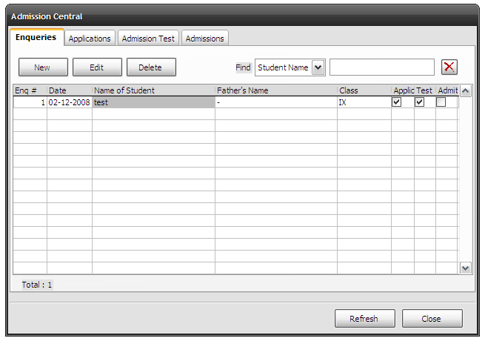
Here the foundation information like inquiries can be managed. You can enter the full inquiry details and that particular can issued an application and can proceed to admission test. Results of various admission tests like admission test, talent test and oral test can be stored along with the marks and status. Then the inquiry can be sent directly to selected admission register without having to enter all the details once again in admission register. From here on, Inquiry will be called as Admission.
Admission Register
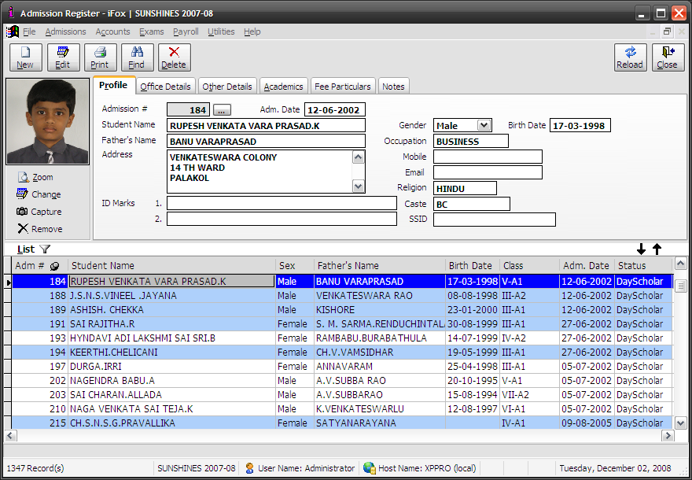
Student Information can be obtained here will be the current and full information. Right from the class studying to academic information and fee particulars can be viewed in pages with ease for selected student. Various reports like Class lists, mailing labels can be generated using combinations of your choice. Student picture can be attached to the record itself. Find will makes it easy to find a particular student studying in your school just with the admission number or part of the student name is enough to filter out the required target. Filters are provided to filter admission records based on your criteria with an advanced approach.

Fee Management
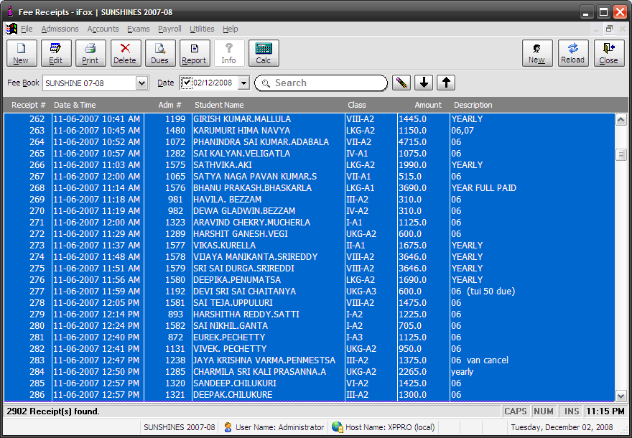
Define your own rules! This is the concept of our fee management module. Create your own fee structure and schedule due dates - all at individual class level. Select a student in fee receipts and you will know the fee amount under various heads that particular student is due to school as on date. Making fee receipts has never been easier before. Just flash the student ID card to the barcode reader and find the receipt ready to print with all the details along with current amount that can be paid to school as on date or for the term along with dues. Find the class wise dues just with a couple of clicks by selecting date and class/classes. Just one more click gives you the daily amount under the fee head.

Security
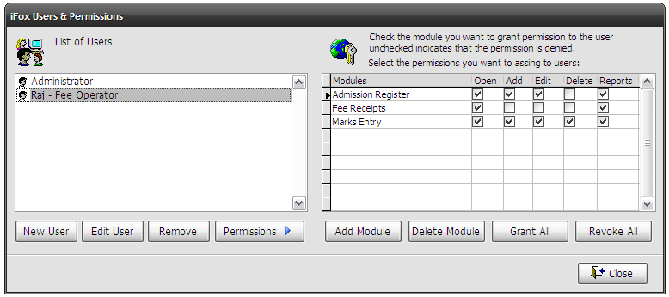
Security has its right place just as to give you control on things. Assign modules and access privileges to individual users based on their role. On-screen options and list of modules lets you give access to items that can be accessed by an operator. All in an easy manner - just see to know. No learning required!
Marks Module
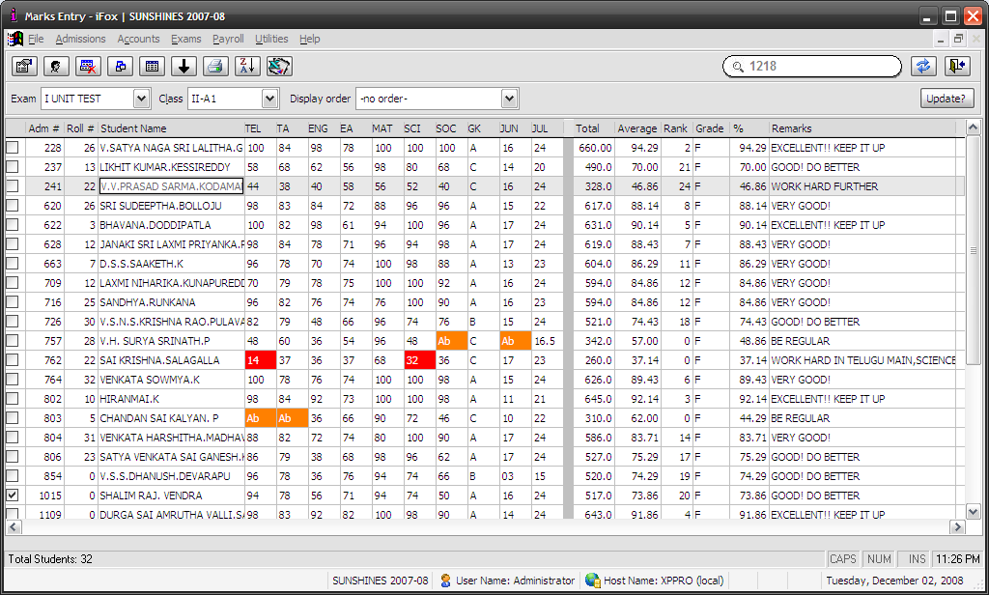
It will be a pleasure to enter marks in a worksheet style marks entry screen. Enter marks and as you see all the calculations and grading will be done on the fly. Automated remarks will be presented to students based on their performance. After all marks entry is done, you can print reports in number of types. An array of reports are available to select from basic progress report, class marks list to result analysis and attendance statement. Reports are even growing to meet user specific requirements with more added features.
onlykishor@gmail.com

